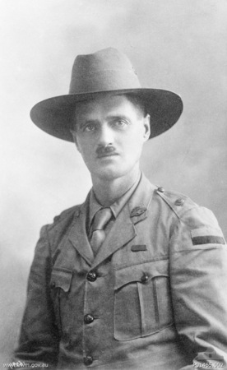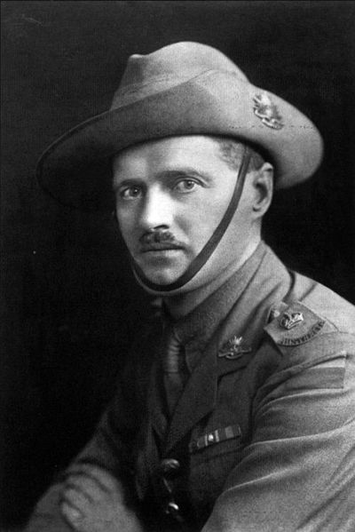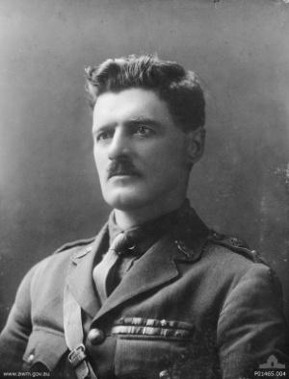

315 Lieutenant Colonel Henry William “Harry” Murray

VC, CMG, DSO & Bar, DCM, CdeG, MID ****

1 December 1880 – 7 January 1966

By Guy Barnett MP

Lieutenant Colonel Harry Murray VC Medal Unveiling
9.45 am, 6 June 2015
Queen Victoria Museum and Art Gallery
Invermay Road, Launceston

- Lieutenant Colonel Harry Murray VC was born of convict descent, one of 9 children on 1 December 1880 in Evandale, a small rural town south of Launceston.
- He left school at 14 years and helped run the family farm as well as joining the Launceston Voluntary Artillery Corps in 1902, where he served for 6 years.
- At the age of 20, Murray moved to Western Australia to join a number of his brothers and for work as a wood cutter and other work in the timber industry. Following the outbreak of war on 30 September 1914, aged 34 years, he enlisted in the Australian Imperial Force as a private.
- Murray landed at Gallipoli on 25 April 1915 as a member of one of the 16th Battalion's 4th Brigade two machine-gun crews. He was incidentally under the command of then Colonel John Monash and was also in the final 200 to depart Gallipoli.
- Murray rose from the rank of Private to Lieutenant Colonel in three and a half years and is now Australia’s most highly decorated soldier and was the most decorated infantry soldiers of the entire British Empire in the First World War. He was described as shy and modest but also ‘the most distinguished fighting officer of the AIF’.

The citations for his awards are as follows

Distinguished Conduct Medal (DCM) Gallipoli May 1915

For distinguished service on several occasions from 9th to 31st May 1915 during operations near Gaba Tepe (Dardenelles) (sic) when attached to the machine-gun section. During this period he exhibited exceptional courage, energy and skill, and inflicted severe losses on the enemy, he being himself twice wounded.

Distinguished Service Order (DSO) The Somme August 1916

Although wounded twice, he commanded his Company with the greatest courage and initiative, beating off four enemy attacks. Later, when an enemy bullet started a man’s equipment exploding he tore the man’s equipment off at great personal risk. He set a splendid example throughout.

Victoria Cross (VC) Stormy Trench, Guedecourt May 1917 (the highest decoration during wartime for bravery in the face of the enemy)

For most conspicuous bravery when in command of the right flank Company in attack. He led his Company to the assault with great skill and courage, and the position was quickly captured. Fighting of a very severe nature followed, and three heavy counter-attacks were beaten back, these successes being due to Captain Murray’s wonderful work. Throughout the night his Company suffered heavy casualties through concentrated enemy shell fire, and on one occasion gave ground for a short way. This gallant officer rallied his command and saved the situation by sheer valour. He made his presence felt throughout the line, encouraging his men, heading bombing parties, leading bayonet charges, and carrying wounded to places of safety. His magnificent example inspired his men throughout.

Bar to DSO Bullecourt May 1917

He rendered conspicuous service for the attack near Bullecourt on 11/4/17. He led his Company with courage and skill through 1,200 yards of shell and machine-gun fire and he and his Company still kept on although they lost 75% of their strength before reaching the second objective. Captain Murray being the senior officer of the 4th Brigade in the 1st and 2nd objectives went along the whole frontage, 900 yards, directing the defence, always encouraging the men of all units by his cheerfulness and bravery and always moving to the points of danger.
When the bomb supply was running out and the men gave ground he rallied them time and time and fought back the Germans over and over again. When there was no alternative but to surrender or withdraw through the heavy machine-gun fire, Captain Murray was the last to leave the position. He is not only brave and daring but a skilful soldier possessing tactical instinct of the highest order. He has already been awarded VC, DSO, DCM.

Croix de Guerre (CdeG) (French) October 1918

During the period 23rd March to 24th April 1918 and 2nd to 7th August 1918 he commanded the 4th Australian machine-gun Battalion with remarkable skill. Under heavy fire from enemy artillery he was successful, by his bravery, in maintaining in the most difficult circumstances a close liaison with French troops.

Companion of the Order of St Michael and St George (CMG) June 1919

This officer has commanded the Machine Gun Battalion of the (4th) Division since its inception on the 15th March 1918. His work has been marked by conspicuous gallantry, ability, tactical knowledge and devotion to duty. During the period 18th September to 11th November he commanded the machine-guns of the Division with marked success in the operations which resulted in the capture of the Hindenburg Outpost Line. He also, as Liaison Machine Gun Officer with the 2nd American Corps, largely contributed to the successful work of the machine-guns of that Corps in the operations resulting in the breaking of the main Hindenburg Line near Bellenglise.
He is recommended for high distinction.

Mentioned in Despatches x 4 (MID***)

Murray was Mentioned in Despatches on 4th January 1917 following a period of patrols and trench raids in late 1916. For his actions at Passchendaele, Murray was garnered a mention in Field Marshal Sir Douglas Haig’s dispatch of 7th November 1917.
His final honour came in 11th July 1919, when he was Mentioned in Despatches for the fourth time, having received his third mention on 31st December 1918.

- In October of 1915 after being wounded once in a machine gun battle with shrapnel in the knee and having had dysentery, he was transported to hospital in Cairo where he was declared ‘unfit for service’. In a letter to his mother on 9 October it was said that he was being returned home to Australia to recuperate. But on being transported to the ship to return he boarded the wrong ship- he boarded the ship to return to Gallipoli and fight with his mates.
- In a letter to his sister Annie Cocker when in Egypt in 1915 he said ‘More than anything I require a rest and change, both of climate and food…how I would love a few days in little old Tasmania’.
- Lieutenant Colonel Murray enlisted again in World War Two and commanded the 26th Battalion in North Queensland until August 1942.
- He retired from the army in early 1944 and returned to his farm ‘Glenlyon’ near Richmond, Queensland until he died on 7 January 1966, aged 86 years.
- Lieutenant Colonel Murray’s family are lending his medals to the Queen Victoria Museum and Art Gallery to display until the end of August 2015. They were previously displayed at QVMAG in 2011 following my request of the family.
- The medals are now returning home to Tasmania once more and it may be the last time we will see them in this state.
- The medals are then making their way to the Australian War Memorial where they will remain in the Hall of Valour permanently on loan from the family.
- The Hall of Valour honours the 100 Australians who have received the Victoria Cross (and the nine Australian Defence personnel who have directly received the George Cross).
- Around Tasmania, there are many other memorials and tributes to Harry Murray, acknowledging his service in the Australian Imperial Force and his many acts of valour.
- A bronze statue of Murray, depicting him in war action, can be seen in his home town of Evandale. David Von Stiglitz and the Murray Memorial committee with my support as a senator, raised the funds for the Murray statue that was unveiled on 24 February 2006 by the Governor General Major General Michael Jeffery. Doug and Clem Murray son and daughter of Harry Murray were present with their many children and grandchildren at the time. Doug gave me the honour then viewing the Victoria Cross and other medals of his Dad.
- It was David Von Stiglitz who stirred me on to ensure Harry Murray was properly recognised as at the AWM as there existed only a post card size photo of Murray and I wrote to the AWM director in 2005 to request something more fitting and in 2006 his portrait was unveiled at the AWM for the first time. (The AWM offered every state an item from the gallery for the Centenary of ANZAC and following discussions with Dr Brendan Nelson director of the AWM in November 2014 the AWM granted the portrait of Murray to Tasmania for the duration of the Centenary of ANZAC.)

- The return home to Tasmania of the medals of Harry Murray is a fitting tribute to Australia’s most decorated soldier and one of fourteen Tasmanian VC winners.

- Harry Murray VC is an icon. He represents for our community the character of the ANZAC in all those who have served- including their courage endurance mateship and sacrifice. As a grateful nation we are indebted and thankful for his leadership and example. As Tasmanians we should be especially proud and honoured. Lest we forget.

